# Resonance Magazine Presentation

Music has a long relationship with writing and printing techniques: musical scores are as old as writing itself, going back to [ancient Babylon](https://en.wikipedia.org/wiki/Musical_notation), and have reached a wider diffusion after Gutenberg’s invention in the 15th century. However, it was only with the explosion of popular music from the 1930s onwards that an entire industry of music magazines, underground fanzines, and prestigious journalism was born. We at Resonance consider ourselves as contemporary heirs of this noble tradition. We are also in dialogue with coeval online magazines like Pitchfork, The Quietus, The Wire, or the Italian SENTIREASCOLTARE. Yet, with Resonance, we aim to offer a different idea of what a magazine could be, stretching the boundaries of **this** hundred-year-old definition. Resonance is a typographical experiment, that allows the reader to experience our articles’ selection through six different stylistic lenses. Digital technologies enable us to give a new spin to the reading experience, making it playful and creative. We are not only interested in the recreational side of things: with the Metadata Viewer, we aim to offer an enhanced reading experience, where entities, places, and other knowledge material can be easily recognized and studied by our readers!

Explore our issues here and read our documentation for technical details!

https://www.music-journalism-history.com/tag/music-fanzines/

# RESONANCE Issue #1 – Digital music economy

The last ten years have shaken music’s economy. After a long crisis, partially caused by pirate software like Napster or Soulseek, big companies have now integrated the streaming economy into their business model. Spotify has become a model for other players in the industry like Amazon Prime Music, Youtube Music, Apple Music, or Deezer. The digital market offered by these services is the largest ever and it seems like everybody can get their shot towards fame: you just need to get viral online and the fans will come. Listeners are happy as well with hundreds of releases every week: the dream of every music lover, the perfect marriage between mainstream and underground circuits is in your pocket. Yet, this model got many weak points: musicians are not paid enough, record labels are more needed than ever for advertising, the top artists got the largest part of revenues and the algorithm becomes the real decision-maker.   
Moreover, in the sad pandemic world of 2020-21, streaming became the only revenue for many artists unable to play concerts and festivals. This situation exacerbated Spotify’s inequalities and many singers and producers turned to Bandcamp, an independent artist-oriented service, and their Bandcamp Friday initiative when revenues are fully donated to the authors. Similar alternative models are getting more and more attention, *in primis* NFT technology, while new formats of online music consumption, as virtual festivals, are also emerging. Eventually, artists are also fighting to get more government recognition and see their work supported during this historical moment.

This issue of RESONANCE is dedicated to the complex and multi-layered world of the music economy, from Swedish billionaires to alternative underground models, trying to learn some lessons valid for the whole digital economic system we live in.

<https://pitchfork.com/features/article/how-musicians-are-fighting-for-streaming-pay-during-the-pandemic/>

<https://www.forbes.com/sites/benjaminlaker/2020/10/28/heres-how-lockdown-has-shown-that-spotify-has-a-sustainability-problem/?sh=73c290c2599b>

## FUTURE STYLE – Low tech

It’s 2035 and we’re losing. Humanity has lost New Dehli, Miami, and Venice: entire areas devasted by severe floodings. Global warming is everyday life and it’s worse than we’ve considered it. After the initial shock, we started to adapt quickly in every field of life. Our beloved Web, which we loved in the innocent ‘90s and hated in the stupid ‘10s, is under trial: in a war economy, you cannot lose any kind of resources and, too many servers are filled with useless pages and flashy websites consuming important energy. Since we can’t simply shut down the web, we now have rationalized its usage, and web design is part of this process.

Thus, the founding work of some projects like LowTechMagazine or Organicbasis is the standard by today: websites are image-free (if not necessary or requested), they are often downloadable or printable on recycled paper to be read offline, and they compress all data to the greatest extent possible and load only the most crucial programming scripts, frameworks, and cookies. Plus, most of the servers rely on renewable energy. Big images, complex graphics, video streaming, and multiple fonts are memories of the past, glories of simpler times.

### Fonts

Regarding the fonts, the best choice from a sustainable point of view is to use default fonts, thus we adopted the classic **Times New Roman.** Why is it so? With the @font-face rule and webfont distributors, it's straightforward to embed a typeface within a website. But they come at a cost: custom fonts impact performance, often adding several seconds of load time to a page. This design leverages these defaults, as it does not declare a font-family at all. This not only avoids having to load more assets, but also reiterates the role of the browser in website access. Moreover, only one weight (regular) of a font is used, demonstrating that a typographic hierarchy can be established without loading multiple typefaces and weights. Basic colors were added to enhance the aesthetic, in this way:

* **Titles** are red, 44px
* **Subtitles** are darkgreengreen, 22px
* **Author and date** are light grey, 20px
* **Text Body** is black

### Images

The lightest websites would exist without any images or graphical elements. That said, imagery is an important part of communicating content. We used several techniques to minimize the server and data load for our images: heavily compressed dithered images, inline SVGs, and image sprites.

So, our images are dithered through the website DitherIt, which allows a different selection of algorithms and color options . Again, a basic color hierarchy is employed with opening images in **darkgreen** and articles images in **blue**Immagine che contiene testo, screenshot, elettronico, grafica vettoriale

On the website is also possible to see how much space is getting saved through the dithering operation. The icons have been dithered throught the Orderd Dither method which reduce images to 8 standard web colors without being able to applying a color palette. Yet, this algorithm works better with small images such as icons.

The background is a neutral color that allows the user to navigate without turning on the brightness of their screen: this is another important factor of energy consumption that needs to be reduced.

Image loading illustration

2. Minimizes the power consumption on the users device.

Minimized power consumption - battery

3. Adapts to reflect the amount of renewable energy it’s currently running on.

Renewable energy - light bulb

4. Informs the user of the impact of their browsing behavior.

User browsing behaviour - search icon

5. Does not make use of videos.

Video usage - play button

6. Stores data locally on the user’s device to minimize data transfer.

Store data locally - mobile phone data transfer

Loading only important scripts, frameworks and cookies

9. Limits the amount of light emitted by the screen.

Light emitted by screens - sun illustration

10. Optimizes and limits the use of custom fonts.

<https://lowimpact.organicbasics.com/eur>

<https://solar.lowtechmagazine.com/>

<https://ecomersh.co.uk/about/>

<https://alistapart.com/article/sustainable-web-design/>

<https://homebrewserver.club/low-tech-website-howto.html#image-compression>

<https://en.reset.org/blog/solar-powered-low-tech-website>

<https://speculum.substack.com/p/collasso-tech>

<https://github.com/lowtechmag/solar/wiki/Solar-Web-Design>

<https://www.forbes.com/sites/christophermarquis/2021/01/15/paper-free-isnt-enough-the-keys-to-sustainable-web-design-for-every-business/?sh=603423c62b12>

<https://endtimes.dev/why-you-should-dither-images/>

<https://www.visualcapitalist.com/cost-of-mobile-data-worldwide/>

https://www.bbc.com/future/article/20200305-why-your-internet-habits-are-not-as-clean-as-you-think

## Stile 2 – Enlightenment

Books played a decisive role in the Enlightenment, elevating European citizens’ consciousness and political awareness to new levels. Thanks to new a greater alphabetization, new discussion places (like cafes), and new techniques, the 1700s saw a greater spreading of printing culture all over Europe but also in America and the East.

### Fonts

Regarding fonts, the Enlightenment period saw a rise in typography with a bigger stroke contrast, stylized shapes with bracketed serifs, and round, bulbous terminals, fitting the Rational spirit of the era. Yet, also a revolutionary and radical aspect was involved, as these fonts are the first to break up with the classical handwritten tradition and to embrace progressively automatic typing: for this reason, they are called *Transisionist* (the most famous being the font *Romains du Roi*). The transition led to the most important trend in the period (particularly, from the second half of the century): the **Neoclassical** style, inspired by the geometric rationale of the Ancient World and expressed in fonts like ***Didot***. The Didot family were among the first to set up a printing press in the [newly independent Greece](https://en.wikipedia.org/wiki/Modern_Greece), which was also a great example of a struggle for national reasons for patriots all over Europe.

Figure 1 Didot's type in the Code civil des Français, printed by the company of Firmin Didot in 1804.

The typeface is based on a collection of related types developed from 1784–1811 by Firmin Didot. Firmin cut the letters and cast them as type in Paris, and his older brother Pierre used them in printing. Firmin was also the inventor of stereotypography, an innovation in the printing process that completely changed the book industry, allowing books to be printed less expensively. This opened book ownership and casual literacy up to the common person. We will consider the **Didot style** as the representative of the Enlightenment and thus build our style using Didot’s books as the main inspiration.

Thus, we adopted two different versions of Didot for our style.

### Layout

Didot’s books were organized according to the typical choices of the Neoclassical spirit: minimal decoration, wide margins, and linear borders characterize their books.

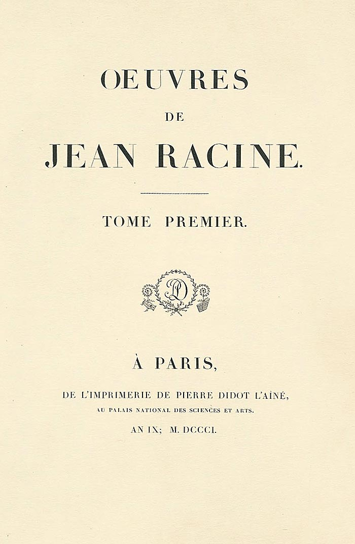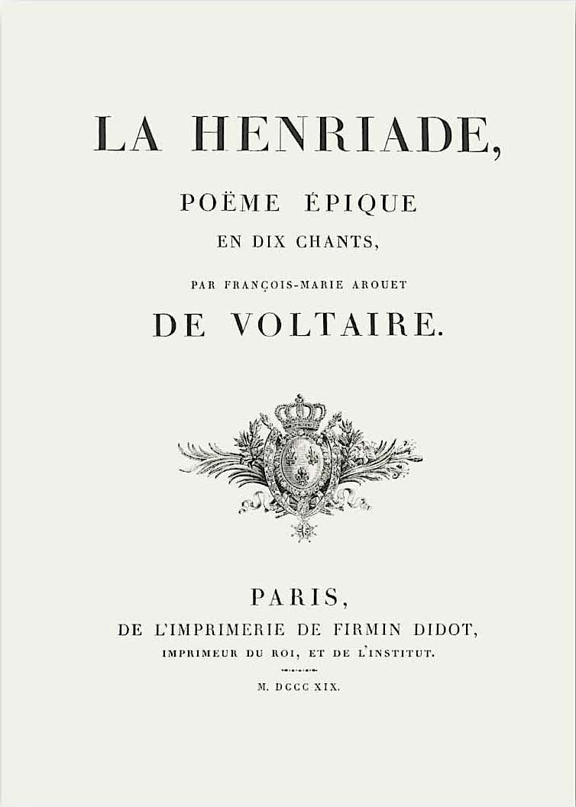

Figure 2 Voltaire was Didot's client

The style adopted for the front page is the one we used for different elements in the articles:

* The **title** is a Didot font, specifically called GFS Didot, all in caps with a semi-bold trait. The margins are wide and the letter spacing is evident so to organize them more vertically the content.
* The **subtitle** is separated from the title by a **small hr element**. It is again in Didot style but a different font called Linotype Didot Roman. and all in caps but without the bold effect. Margins, letter spaces, and line-height are wide to give the content a more vertical structure like in Didot’s books.
* The **Didot Logo separates** subtitles from the **authors** and **publication date**, which are a smaller version of the subtitle (20px instead of 30px)

Figure 3 Page-spread from "Collection des moralistes anciens" printed by François-Ambroise Didot in 1782—1783. Here is volume 10.

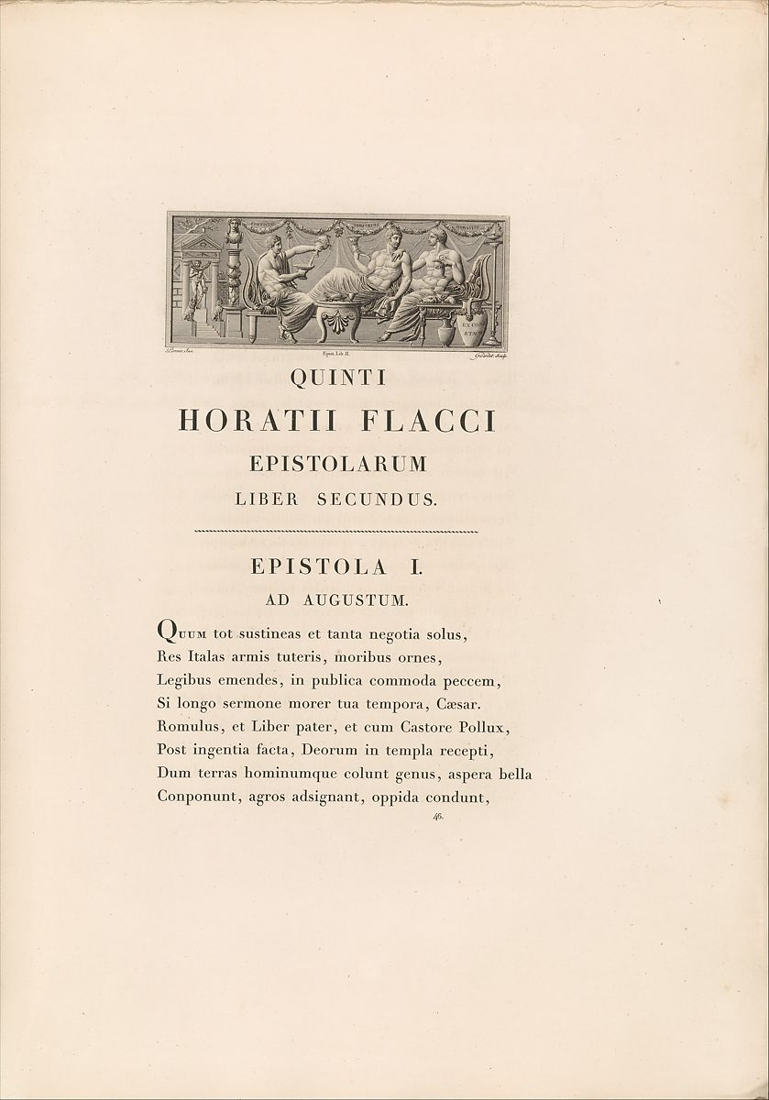

Figure 4 This is the second book in Didot's five-part project known as the "Louvre editions" (1798–1816). Situated between The Works of Virgil and The Works of Racine, it marked the pivotal transition in Didot's suite between authors from antiquity and those from

* The **paragraph title** is again all caps, with wide letter spacing and a small hr element above separating from the body. This takes it back from the title style and it is GSF Didot with boldness.
* The **first letter** of the body of the text is bigger and bolder compared to the rest.
* The **body** is GFS Didot with 40px margin and 2px letter spacing to reproduce the elegant and spacious style of Neoclassical typography.
* The **background** is a paper-like texture reproducing the typical paper colour of the time.



* The **images** are filtered with a classic **sepia** effect to reproduce the paper’s color.

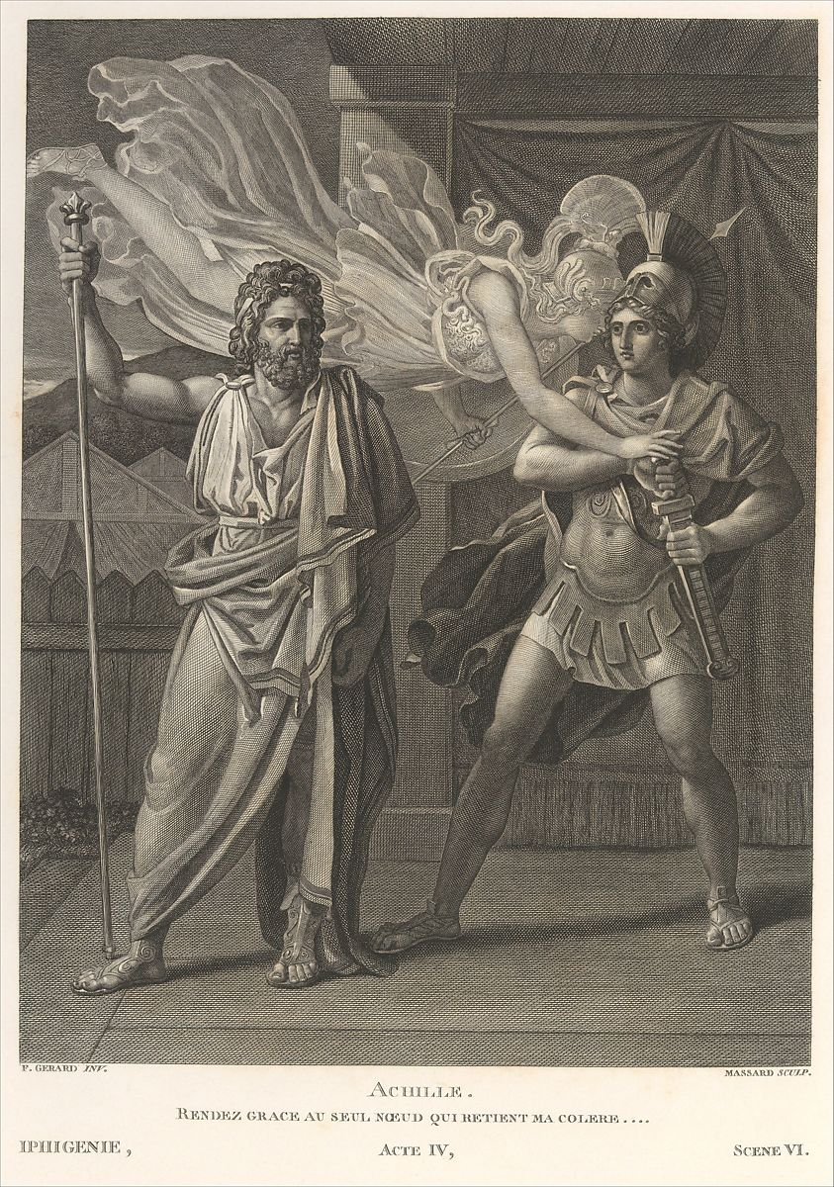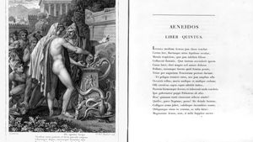

### Bibliography

<https://en.wikipedia.org/wiki/Didot_(typeface)>

<https://medium.com/@redheadedmandy/didot-typeface-d38ee7c02c4c>

<https://ilovetypography.com/2008/05/30/a-brief-history-of-type-part-4/>

https://www.metmuseum.org/art/collection/search/351789

